1. Added I2C header (PL12)

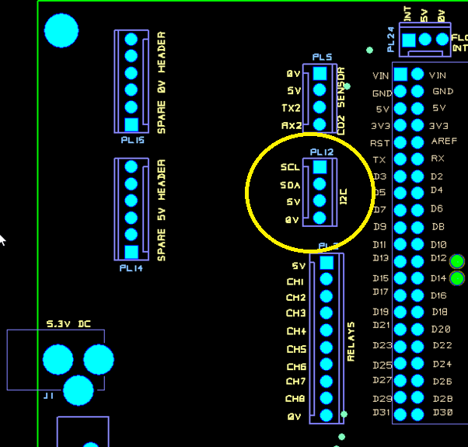

1. Add TFT jumper select 3V3 or 5V (PL28)

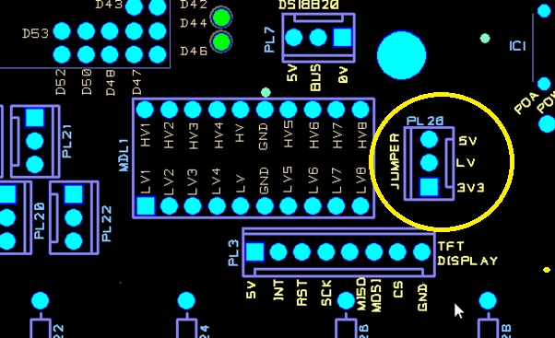

1. Add Analog potentiometer (R31) as an alternative to digital with DIP switches (S2).

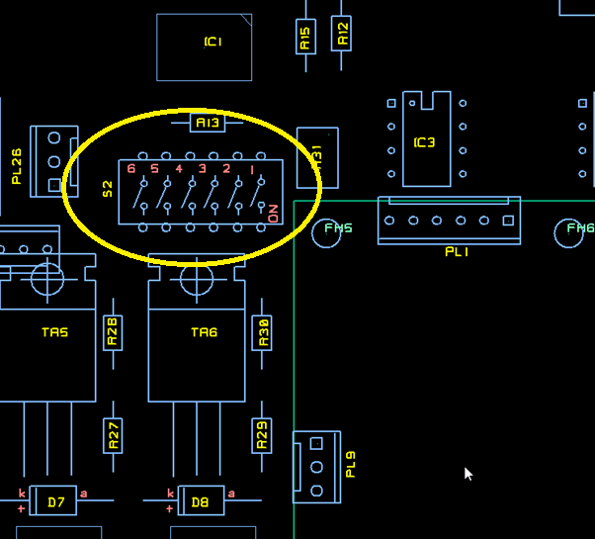

1. Add adjustable switching (Boost) regulator to power the pumps (MDL6).

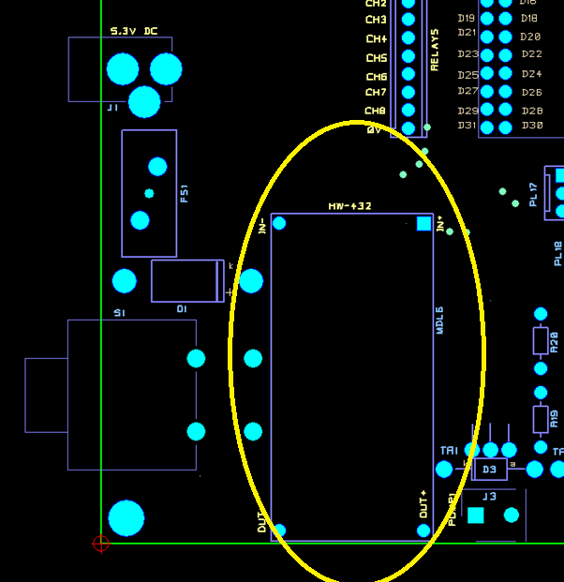

Overall board shown

Top side

Bottom side (looking through board)

